190905104
Parth Shukla
Lab 8
Study of Dynamic Routing Protocols using GNS3

1)

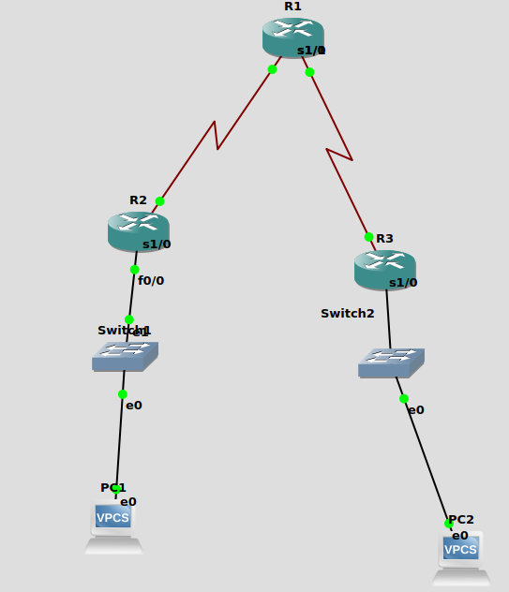
Network details:
PC1 – IP address 172.16.2.10 default gateway 172.16.2.1
PC2 – IP address 10.2.2.10 default gateway 10.2.2.1
R1 – s1/0 IP address 100.1.1.2
R1- s1/1 IP address 20.1.1.1
R2 – F0/0 IP address 176.16.2.1
R2 – s1/0 IP address 100.1.1.1
R3 – F0/0 IP address 10.2.2.1
R3 – s1/0 IP address 20.1.1.2

Setting up router accordin to the manual,
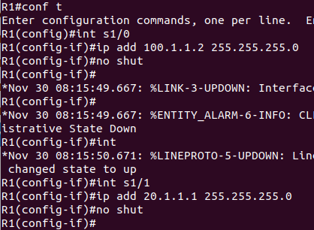
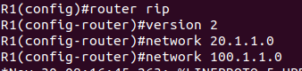

Router is set up using RIPv2 protocol. The network command is used to specify the directly connected subnets on the router to be configured and that are intended to be included in the routing updates.

R2 and R3 are also set up similarly.

Checking if PC1 and PC2 can communicate:
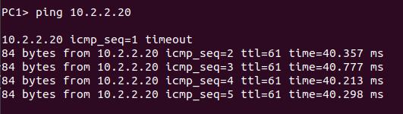
show ip route for R1:
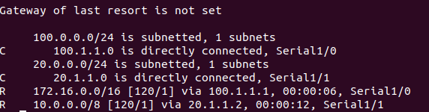
All paths to networks can be seen. Eg- 100.1.1.0 is directly connected to R1, 172.16.0.0 is connected via 100.1.1.1
Routing protocol is RIP can be checked by,
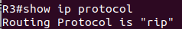

RIP database shows all the networks reachable and how they can be reached.
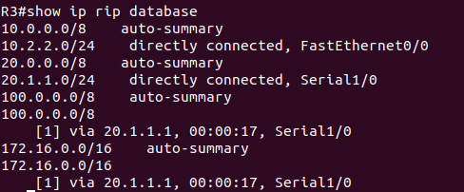

2)

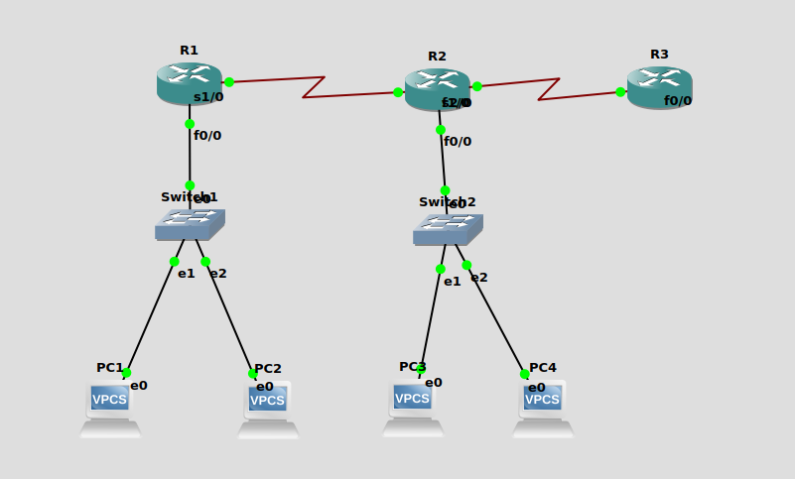
Network details

R1 – s1/0 – IP address 192.168.1.1
R1 – F0/0 - IP address 10.0.0.1
R2 – s2/0 - IP address 192.168.1.2
R2 – F0/0 - IP address 20.0.0.1
R2 – F1/0 - IP address 150.150.150.1
R3 – F0/0 - IP address 150.150.150.2
PC1 - IP address 10.0.0.2 defualt gateway 10.0.0.1
PC2 – IP address 10.0.0.3 default gateway 10.0.0.1
PC3 - IP address 20.0.0.2 default gateway 20.0.0.1
PC4 - IP address 20.0.0.3 default gateway 20.0.0.1

After assigning IP addresses to Routers and PC, we put the commands mentioned in the manual.
Like -
R1(config)#router ospf 200
R1(config-router)#network 10.0.0.0 0.255.255.255 area 0
R1(config-router)#network 192.168.1.0 0.0.0.255 area 0.0.0.0
R1(config-router)#exit

router ospf 200 defines the routing protocol to be followed id ospf.
The usage of network command is - network network wildcard-mask area area-id. The network command is used to identify which device interface will be included within the OSPF process and to what area the interface will be assigned to.

After following these steps, we can communicate between the Pcs.
Ping PC3 from PC1
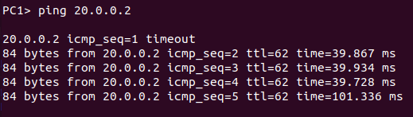
Ping R3 from PC1
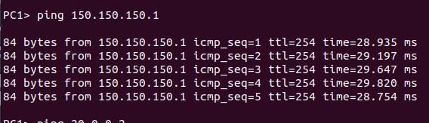
show ip route can be used to check all the routes in the router
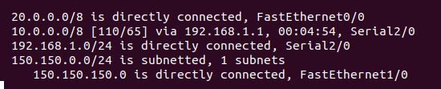
Here, we can see R2 is directly connected to network 20.0.0.0 and connected to network 10.0.0.0 via 192.168.1.1, etc.
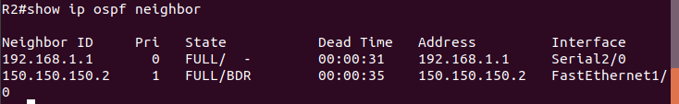
Show ip ospf neighbor can be used to observe the neighbors of the router. Neighbors are directly connected IP addresses of other routers to which packets are directly passed.

Show ip ospf database shows all the routes in the router.
In this example, R2 is included in two areas, one with R1 and one with R3.

For both areas, it gives separate links. For Area 0, Router link states are mentioned. It mentions the Link ID which is the Router ID and also gives the Link count which is the number of interfaces detected for router.

